* Sharing data between Applications with Content Providers

In [Android](https://www.geeksforgeeks.org/introduction-to-android-development/), Content Providers are a very important [component](https://www.geeksforgeeks.org/components-android-application/)that serves the purpose of a relational database to store the data of applications. The role of the content provider in the android system is like a central repository in which data of the applications are stored, and it facilitates other applications to securely access and modifies that data based on the user requirements. Android system allows the content provider to store the application data in several ways. Users can manage to store the application data like images, audio, videos, and personal contact information by storing them in [**SQLite Database**](https://www.geeksforgeeks.org/introduction-to-sqlite/)**, in files**, **or even on a network**. In order to share the data, content providers have certain permissions that are used to grant or restrict the rights to other applications to interfere with the data.

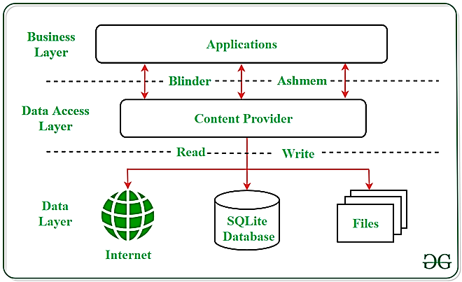

**Content URI**

**Content URI(Uniform Resource Identifier)**is the key concept of Content providers. To access the data from a content provider, URI is used as a query string.

Looking to become an expert in Android App Development? Whether you're a student or a professional aiming to advance your career in mobile app development

***Structure of a Content URI:*** *content://authority/optionalPath/optionalID*

**Details of different parts of Content URI:**

* **content:// –**Mandatory part of the URI as it represents that the given URI is a Content URI.
* **authority –**Signifies the name of the content provider like contacts, browser, etc. This part must be unique for every content provider.
* **optionalPath –**Specifies the type of data provided by the content provider. It is essential as this part helps content providers to support different types of data that are not related to each other like audio and video files.
* **optionalID –**It is a numeric value that is used when there is a need to access a particular record.

**Operations in Content Provider**

Four fundamental operations are possible in Content Provider namely **Create**, **Read**, **Update**, and **Delete**. These operations are often termed as **CRUD operations**.

* **Create:**Operation to create data in a content provider.
* **Read:**Used to fetch data from a content provider.
* **Update:**To modify existing data.
* **Delete:**To remove existing data from the storage.

**Working of the Content Provider**

UI components of android applications like [Activity](https://www.geeksforgeeks.org/activity-lifecycle-in-android-with-demo-app/)and [Fragments](https://www.geeksforgeeks.org/introduction-fragments-android/)use an object **CursorLoader**to send query requests to **ContentResolver.**The ContentResolver object sends requests (like create, read, update, and delete) to the **ContentProvider**as a client. After receiving a request, ContentProvider process it and returns the desired result. Below is a diagram to represent these processes in pictorial form.

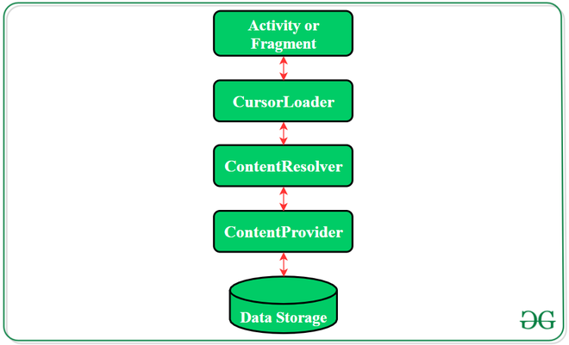

**Creating a Content Provider**

Following are the steps which are essential to follow in order to create a Content Provider:

* Create a class in the same directory where the that **MainActivity**file resides and this class must extend the ContentProvider base class.
* To access the content, define a content provider URI address.
* Create a database to store the application data.
* Implement the **six abstract methods**of ContentProvider class.
* Register the content provider in **AndroidManifest.xml**file using **<provider> tag**.

**Following are the six abstract methods and their description which are essential to override as the part of ContenProvider class:**

| **Abstract Method** | **Description** |
| --- | --- |
| query() | A method that accepts arguments and fetches the data from the  desired table. Data is retired as a cursor object. |
| insert() | To insert a new row in the database of the content provider.  It returns the content URI of the inserted row. |
| update() | This method is used to update the fields of an existing row.  It returns the number of rows updated. |
| delete() | This method is used to delete the existing rows.  It returns the number of rows deleted. |
| getType() | This method returns the Multipurpose Internet Mail Extension(MIME)  type of data to the given Content URI. |
| onCreate() | As the content provider is created, the android system calls  this method immediately to initialise the provider. |